**Clinical Librarian Service Search Results**

**Request:** What literature is available on trends in presentation to ED with COVID-19? In particular, is there any literature providing timings for presentations at ED?

**Summary**

A search of good quality resources has retrieved almost no literature specifically relating to timings and trends in presentation to ED with COVID-19 symptoms. It appears that until now, the main focus of trends literature has been on epidemiology and global spread of infection, and impact on critical care/ICUs, rather than on trends in presentations to EDs.

The search has retrieved some anecdotal reports from Italy:

* A brief article, (2020)1, quotes Roberto Cosentini, Head of the ED at a hospital in Bergamo, who states: *"It's like a wave," he says. "We have now around 60-80 new COVID-19 patients per day coming to the emergency. Most of them are in severe conditions and they arrive all together between 4 and 6 pm. We learnt that the respiratory distress worsens at the end of the afternoon and we now know that we will have to deal with most of the severe cases showing up one after another in a short time, every day."*
* A paper by Giwa et al., (2020)2, in which an Italian ED physician, also from Bergamo, notes that: *“Patients come in waves, usually in the late afternoon”.*

A further paper, Cao, et al., (2020)3, reports on hospital emergency planning for COVID-19 in Chengdu, China. In this paper, the authors do not specific timings for patients to present at ED, but do comment on *“fever visits”* during a five day period, giving percentages: *“The fever visits at the ED soared from January 20 to 25. The ratio of fever patients at the ED exploded to a peak of over 40% on January 25, then fluctuated at about 30%”.*

The search did retrieve a small amount of literature concerning the re-design/development of ED services to manage COID-19 patients. However, this has not been included here, due to the lack of trends data. Should any of this literature be of use, it can easily be supplied on request.

I hope that I have interpreted your request correctly. Please let me know if you would like me to search further.

**___________________________________________________________________**

**Accessing Articles**

Links are provided where online access to the full-text is available. An OpenAthens username and password may be required for online access to articles. You can register for one here: <https://openathens.nice.org.uk/>

Unfortunately there may occasionally be some problems accessing the links provided. In this case the items can be accessed via the Library Journals link: <http://journals.nice.org.uk/>. [Log in to OpenAthens via the link in the top tight-hand corner].

If the full-text is not available, you can request an Inter-Library Loan freely and directly via our Inter-Library Loans system: CLIO. Register for CLIO (using your library membership number) at: [https://derbyill.cliohosting.co.uk](https://derbyill.cliohosting.co.uk/). Further information can be found at: <http://www.uhdblibrary.co.uk/ills>.

**Feedback**

Once you have read this report, I would appreciate it if you would complete our online literature search feedback form at:

<https://www.smartsurvey.co.uk/s/LiteratureSearchFeedback20192020/>

This relates to this specific search and will help us to monitor and improve our service.

Many Thanks.

Lisa Lawrence

Clinical Librarian

Lisa.Lawrence4@nhs.net

ext. 88155

**Current at:** 26th March 2020.

**Time taken for search:** 3.5 hours.

**Please acknowledge this work in any resulting paper or presentation as:**

Evidence Search: LS403 Trends in presentation to ED with COVID-19. Lisa Lawrence. (26/03/2020). Derby, UK: University Hospitals of Derby & Burton NHS Foundation Trust Library and Knowledge Service.

**Disclaimer:** Please note that the information supplied by the Library and Knowledge Service in response to a literature search is for information purposes only. Every reasonable effort will be made to ensure that this information is accurate, up-to-date and complete. However, it is possible that it may not be representative of the whole body of evidence. No responsibility can be accepted by the Library for any action taken on the basis of this information.

Guidance or information relating to specific drug queries or procedures should be referred to Medicines Information on RDH ext. 85379 or Burton ext. 5168 or 5101.

Email: [UHDB.MedicinesInformation@nhs.net](mailto:UHDB.MedicinesInformation@nhs.net)

For local UHDB guidelines and policies please refer to the red button on the Trust intranet, or [**https://derby.koha-ptfs.co.uk/cgi-bin/koha/opac-main.pl**](https://derby.koha-ptfs.co.uk/cgi-bin/koha/opac-main.pl)

**Results**

1. **COVID-19: What Can the World Learn from Italy?**

**Author(s):** Ovadia, D.

**Date:** 13 March 2020.

**Extract:** *“Roberto Cosentini, head of the Emergency Department at Pope John XXIII Hospital in Bergamo, one of the most affected cities, has been living in the hospital for the last 3 weeks: "It's like a wave," he says. "We have now around 60-80 new COVID-19 patients per day coming to the emergency. Most of them are in severe conditions and they arrive all together between 4 and 6 pm. We learnt that the respiratory distress worsens at the end of the afternoon and we now know that we will have to deal with most of the severe cases showing up one after another in a short time, every day."*

**Source:** Medscape.

**Full Text/URL:** <https://www.medscape.com/viewarticle/926777>

1. **Novel 2019 Coronavirus SARS-CoV-2 (COVID-19): An Updated Overview for Emergency Clinicians - 03-23-20**

**Author(s):** Giwa AL, Desai A, Duca A.

**Citation:** Emerg Med Pract. 2020 May 1;22(5):1-28. Epub 2020 Mar 24.

**Extract:** Extract of Table 1 – Accessed 26/03/2020.

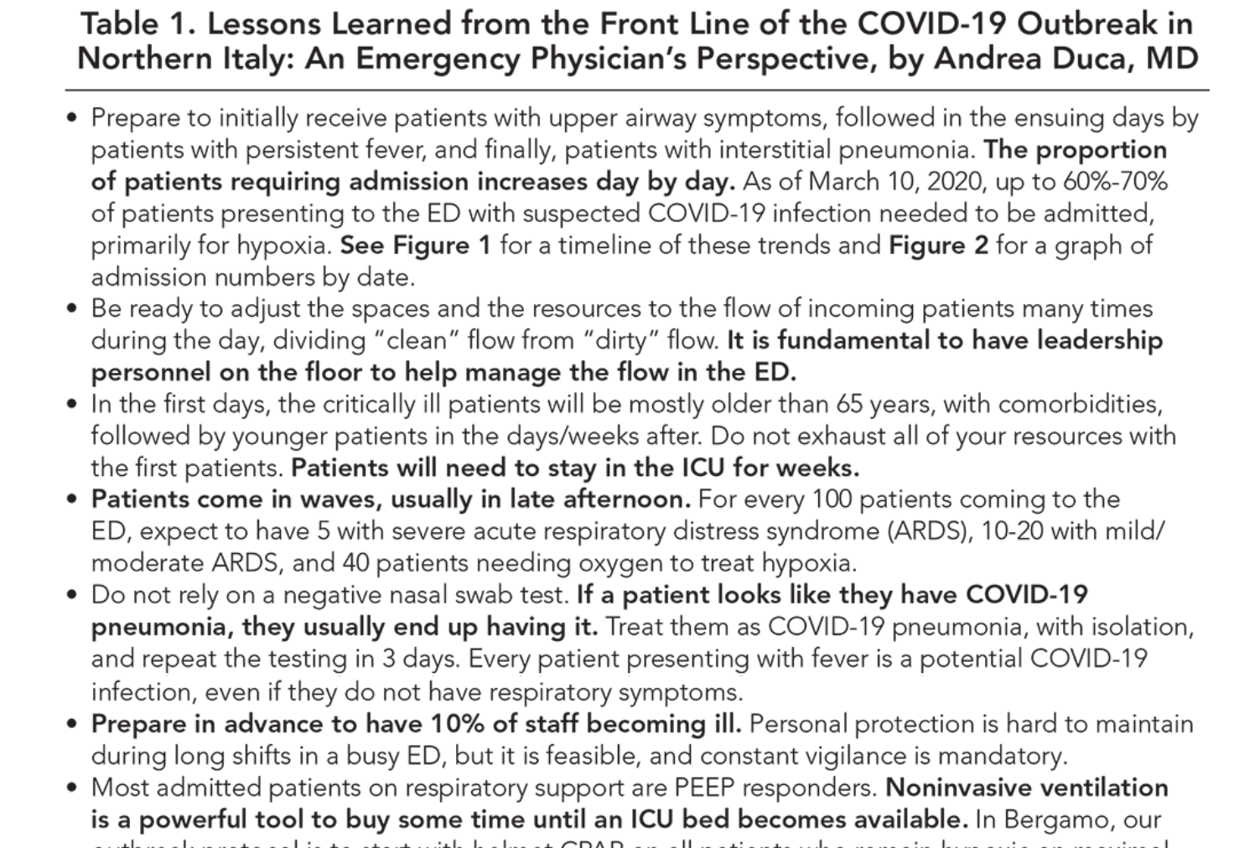

**Source:** EB Medicine.

**Full Text/URL:**

<https://www.ebmedicine.net/topics/infectious-disease/COVID-19?fbclid=IwAR3ondfBEgmR8sxE7MgVgYOnga1SiRbaED4V9-v9ZDfODaWoqVlgbHq2bA4>

1. **Hospital Emergency Management Plan During the COVID-19 Epidemic.**

**Author(s):** Cao, Yubin; Li, Qin; Chen, Jing; Guo, Xia; Miao, Cheng; Yang, Hui; Chen, Zihang; Li, Chunjie

**Source:** Academic emergency medicine : official journal of the Society for Academic Emergency Medicine; Mar 2020

**Publication Type(s):** Letter

**PubMedID:** 32124506

Available at [Academic emergency medicine : official journal of the Society for Academic Emergency Medicine](https://onlinelibrary.wiley.com/doi/full/10.1111/acem.13951) - from Wiley Online Library

Available at [Academic emergency medicine : official journal of the Society for Academic Emergency Medicine](https://onlinelibrary.wiley.com/doi/pdfdirect/10.1111/acem.13951) - from Unpaywall

**Extract:** *“The fever visits at the ED soared from January 20 to 25. The ratio of fever patients at the ED exploded to a peak of over 40% on January 25, then fluctuated at about 30% [Figure 1A]”.*

Figure 1A – Extract from figure with paper. Accessed 26/03/2020.

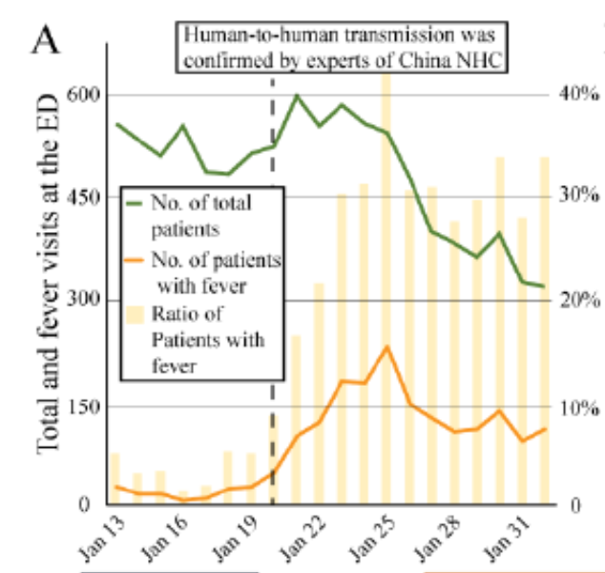

**Database:** Medline

1. **Blog - COVID-19: A Powerful Message from Italy.**

**Author(s):** Rezaie, Salim.

**Date:** 20 March 2020.

**Extract:** *“Physician Schedule Re-Organized:*

* *8 physicians 7am - 2pm*
* *8 physicians 2pm - 9pm*
* *4 physicians 9pm - 7am*

*…*

*We had a sudden increase in patients suspected of having COVID infection from 8 patients on 02/22 to a maximum of 80 patients on 03/06.*

*…*

*We observed 4 phases of ED presentation. The first patients presented with high airway symptoms, most of the time not needing admission, while in the next few days we started to see patients with persisting fever, followed by lower airway symptoms, needing oxygen and, in many cases, ventilatory support, while in the last days we are observing mainly pneumonia patients with a shift of age under 60 years of age”.*

**Source:** Rebel EM – Emergency Medicine Blog.

**Full Text/URL:** <https://rebelem.com/covid-19-a-powerful-message-from-italy/>

1. **2019-ncov's epidemic in middle province of northern Italy: impact, logistic & strategy in the first line hospital.**

**Author(s):** Gagliano A, Villani PG, Cò FM, Paglia S, Bisagni PAG, Perotti GM, Storti E, Lombardo M.

**Citation:** Disaster Med Public Health Prep. 2020 Mar 24:1-15. doi: 10.1017/dmp.2020.51. [Epub ahead of print]

**Extract:** “*The Director of the ED instituted from the first case a careful data collection of the number and trend of patient access. In the first day we received patients with a rate of high flux access every 12 hours for a total number of 120”.*

**Source:** PubMed PMID: 32207676

**Full Text/URL:**

<https://www.cambridge.org/core/services/aop-cambridge-core/content/view/AAEA381A70676F0A4505A23C2D006C62/S1935789320000518a.pdf/2019ncovs_epidemic_in_middle_province_of_northern_italy_impact_logistic_strategy_in_the_first_line_hospital.pdf>

Back to top

**Databases searched:**

* + **Evidence-Based Reviews/Point-of-Care:** Cochrane Library, UpToDate.
  + **Guidance:** NICE Guidance, selected International Guidelines.
  + **Healthcare Databases:** MEDLINE, EMBASE, PubMed.
  + **Other:** Google, Google Scholar, medRxiv, CLIN-LIB – Clinical Librarians mailing list, LIS-Medical mailing list, World Health Organization COVID-19 collection, Cochrane Collaboration Critical Care Collection, NEJM/Lancet/BMJ/Elsevier COVID-19 collections, Royal College of Emergency Medicine.

**Local Guidance:** Local guidance has not been searched as part of this literature search. However, local guidelines, policies and procedures are available via the red button on the intranet.

**Search Terms:**

|  |  |
| --- | --- |
| ***Subject Headings*** | ***Free Text Words*** |
| Betacoronavirus | “A and E” |
| Coronavirus Infections | “Accident and emergency” |
| Emergency Service, Hospital | 2019nCoV |
|  | CoV2 |
|  | “CoV 2” |
|  | COVID-19 |
|  | “covid 19” |
|  | Emergency department |
|  | Emergency presentation |
|  | nCoV |
|  | “novel CoV” |
|  | “novel coronavirus” |
|  | Present* |
|  | Presentation |
|  | Presentations |
|  | SARS-CoV-2 |
|  | sarscov2 |
|  | Trend |
|  | Trends |

**Search Limits:** English language, 2020.

**Search Date: 26/03/2020**

**___________________________________________________________________**

Back to top